**UNIT-IV**

**TESTING OF 3-Ø INDUCTION MOTOR**

* **BRAKE TEST:**

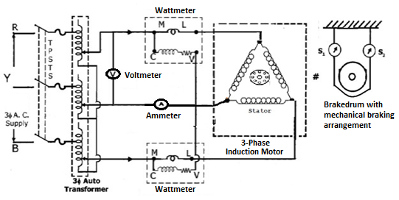

**Figure 4.1 circuit diagram of brake test on 3-Øinduction motor**

The load test on induction motor is performed to compute its complete performance i.e. torque, slip, efficiency, power factor etc. During this test, the motor is operated at rated voltage and frequency and normally loaded mechanically by brake drum and belt arrangement as shown in fig. 4.1. From the observed data, the performance can be calculated, following the steps given below.

**SLIP:** The speed of rotor, Nr droops slightly as the load on the motor is increased. The synchronous speed, Ns of the rotating magnetic field is calculated, based on the number of poles, P and the supply frequency, f i.e.

Synchronous speed, Ns =  Rpm

Then, slip, S = Percent

Normally, the range of slip at full load is from 2 to 5 percent.

**TORQUE:** Mechanical loading is the most common type of method employed in laboratories, a brake drum is coupled to the shaft of the motor and the load is applied by tightening the belt, provided on the brake drum. The net force exerted at the brake drum in kg is obtained from the readings S1 and S2 of the spring balances i.e.

Output = Torque x Speed

Thus as the speed of motor does not vary appreciably with load torque will increase with increasing load.

Net force exerted, W = (S1 – S2) kg

Then, load torque, T = W x d/2 kg – m = W x d/2 x 9.8 Nw– m

Where, d – effective diameter of the brake drum in meters.

**OUTPUT POWER, P0:** The output power in watts developed by the motor is given by,

Output power, P0 = 2 πNT/60 watts

Where, N is the speed of the motor in r. p. m.

**INPUT POWER:** Input power is measured by the two wattmeter method. Two single phase wattmeters connected in the circuit as shown in fig.4.1.

Therefore Input power = (W1 + W2) watts

Where, W1 and W2 are the readings of the two wattmeters.

**POWER FACTOR:** Input power factor can also be calculated from the readings of two wattmeters for balanced load. If Ø is the power factor angle, then

Tan Ø =

From the above equation compute the power factor angle (Ø) and calculate the power factor cos(Ø). It may be noted clearly at this stage, that the power factor of the induction motor is very low at no load, hardly 0.1 to 0.25 lagging. As such, one of the wattmeter will record a negative reading, till the power factor is less than 0.5, which may be measured by reversing the connection of either the current coil or pressure coil of this wattmeter.

**EFFICIENCY:** Percentage efficiency of the motor, %η = (Output power / Input Power) *100

Full load efficiency of 3 phase induction motor lies in the range of 72 % (for small motors) to 82 % (for very large motors).

**SPEED:** When the induction motor is on NO-LOAD speed is slightly below the synchronous speed. The current due to induced emf in the rotor winding is responsible for production of torque required at NO-LOAD. As the load is increased the rotor speed is slightly reduced. The emf induced in the rotor causes the current increased to produce higher torque, until the torque developed is equal to torque required by load on motor.

**PROCEDURE:**

1. Connect the circuit as per fig.4.1

2. Ensure that the motor is unloaded and the variac is set at zero output voltage.

3. Switch-on 3 phase ac mains and start the motor at reduced applied voltage. Increase the applied voltage, till its rated value.

4. Observe the direction of rotation of the motor. In case, it is reverse, change the phase sequence of the applied voltage.

5. Take-down the readings of all the meters and the speed under no load running.

6. Increase the load on the motor gradually by turning of the hand wheels, thus tighten the belt. Record the readings of all the meters and the speed at every setting of the load. Observation may be continued upto the full load current rating of the motor.

7. Reduce the load on the motor and finally unload it completely.

8. Switch-off the supply to stop the motor.

9. Note-down the effective diameter of the brake drum.

# **No Load Test & Blocked rotor Test of Induction Motor**

The induction motors are widely used in the industries and consume maximum power. The efficiency of large motors can be determined by directly loading them and by measuring their input and output powers. For larger motors it may be difficult to arrange loads for them. Moreover, power loss will be large with direct loading tests. To improve its performance characteristics certain tests have been designed like no-load test and blocked rotor test, etc.

## **No Load Test of Induction Motor**

In this test Rated voltage is applied to the motor without load on the motor. The motor is rotate at near synchronous speed and no load current to fulfil core losses and mechanical losses. This test is conducted by the circuit diagram as shown in fig. 4.1 without load ie keep brake drum free to rotate.

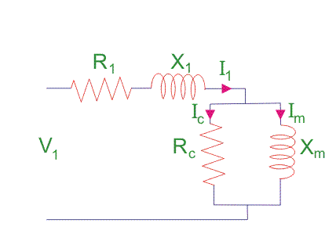

Figure 4.2. No Load test equivalent circuit

From No-Load test results calculate the No-Load equivalent circuit(fig.4.2.) parameters as follows

## Let the total input power supplied to induction motor be W0 watts.

## http://www.electrical4u.com/images/february16/1456563947.GIF

## Where, V1 = line voltage

I0 = No load input current

Rotational loss = W0 – S1

Where, S1 = stator winding loss = 3Io2R1

Where, I0 = No load input current

R1 = Resistance of the stator/phase

## **Blocked Rotor Test of Induction Motor**

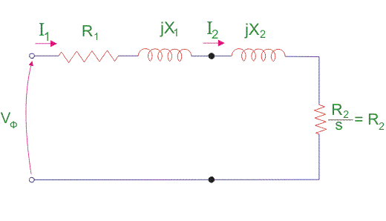

Figure 4.3. Blocked rotor test equivalent circuit

Blocked Rotor test equivalent circuit of induction motor is as shown in figure 4.3.

In block rotor test, rotor is blocked with the help of braking arrangement as shown in fig.4.1. Supply given the stator through auto transformer, apply reduced voltage by adjusting auto trans former until stator current reached to full load stator current. Then record the readings.

From the blocked rotor test results determine the equivalent circuit parameters as follows

In blocked rotor test, core losses are very low due to the supply of low voltage and frictional loss is also neglected as rotor is stationary, but stator cupper losses and the rotor cupper losses are reasonably high. Let us take denote copper loss by Wcu

Therefore,

https://www.electrical4u.com/images/february16/1456568523.GIF

Where, R01 = Motor winding resistance of stator and rotor as per phase referred to stator. Thus,

https://www.electrical4u.com/images/february16/1456569236.GIF

Now let us consider Is = short circuit current

Vs = short circuit voltage

Z0 = short circuit impedance as referred to stator https://www.electrical4u.com/images/february16/1456569646.GIF

Therefore, X01 = Motor leakage reactance per phase referred to stator can be calculated as https://www.electrical4u.com/images/february16/1456570231.GIF

Stator reactance X1 and rotor reactance per phase referred to stator X2 are normally assumed equal. Therefore

https://www.electrical4u.com/images/february16/1456671809.gif

Similarly, stator resistance per phase R1 and rotor resistance per phase referred to stator R2 can be calculated as follows:

First some suitable test are done on stator windings to find the value of R1 and then to find R2 subtract the R1 from R01

https://www.electrical4u.com/images/february16/1456570524.GIF

**Circle Diagram for Three Phase Induction Motors**

Circle diagram is very much useful to predict the induction motor performance. Circle is drawn with the help of No-Load and Blocked rotor tests results as follows

**No-load Test results**

Supply line voltage = *V0*,

No-load line current = *I0,*

No-load power = *P0*.

Phase angle for no-load condition

**Blocked Rotor Test results**

Short circuit (Blocked rotor) voltage = *VSC*,

Short circuit (Blocked rotor) voltage = *ISC*

Short circuit (Blocked rotor) power = *PSC*.

Phase angle for blocked rotor condition

Current drawn if rated voltage is applied at blocked rotor condition

Power input at rated voltage and motor in the blocked rotor condition

**Resistance Test**

By voltmeter-ammeter method determine

per phase equivalent stator resistance = *R1*.

If the machine is wound rotor type,

Per phase equivalent rotor resistance = *R2′*

after measuring rotor resistance and required transformations are applied.

**Construction of Circle Diagram**

1. Draw horizontal axis OX and vertical axis OY. Here the vertical axis represents the voltage reference.
2. With suitable scale, draw phasor OA with length corresponding to *I0* at an angle *Φ0* from the vertical axis. Draw a horizontal line AB.
3. Draw OS equal to *ISN* at an angle *ΦSC* and join AS.
4. Draw the perpendicular bisector to AS to meet the horizontal line AB at C.
5. With C as centre, draw a semi-circle passing through A and S. This forms the circle diagram which is the locus of the input current.
6. From point S, draw a vertical line SL to meet the line AB.
7. Fix the point K as below.

For wound rotor machines where equivalent rotor resistance *R2*′ can be found out:

Divide SL at point K so that SK: KL = equivalent rotor resistance: stator resistance.

For squirrel cage rotor machines:

Find Stator copper loss using *ISN* and stator winding resistance *R1*.

Rotor copper loss = total copper loss – stator copper loss.

Divide SL at point K so that SK : KL = rotor copper loss : stator copper loss

***Note*:** If data for separating stator copper loss and rotor copper loss is not available then assume that stator copper loss is equal to rotor copper loss. So divide SL at point K so that SK= KL

1. For a given operating point P, draw a vertical line PEFGD as shown

Then, PD = input power, PE = output power, EF = rotor copper loss, FG = stator copper loss, GD = constant loss (iron loss + mechanical loss)

9. Efficiency of the machine at the operating point P,

10. Power factor of the machine at operating point P = cosΦ1

11. Slip of the machine at the operating point P,

12. Starting torque at rated voltage (in syn. watts) = SK

13. To find the operating points corresponding to maximum power and maximum torque, draw tangents to the circle diagram parallel to the output line and torque line respectively. The points at which these tangents touch the circle are respectively the maximum power point (Pmax) and maximum torque point (Tmax)

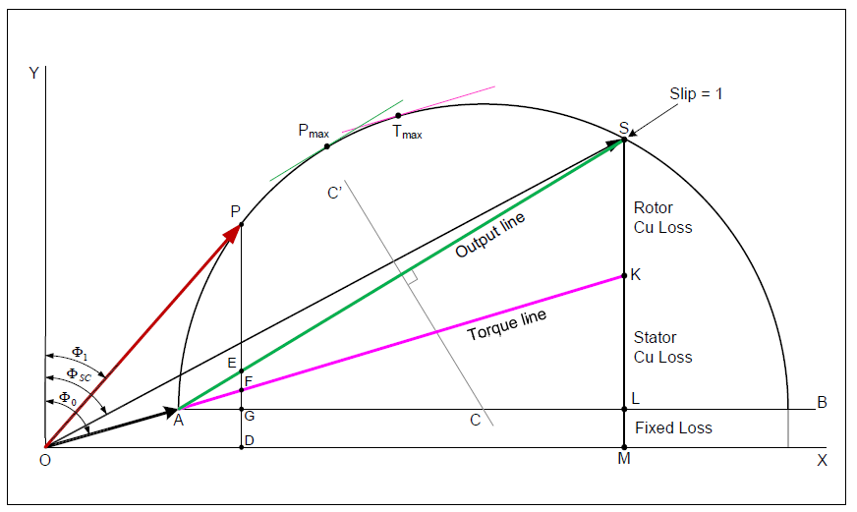**Figure 4.4 circle diagram**

**Starting Methods of 3-Phase Induction Motors**

The method to be employed in starting a given induction motor depends upon the size of the motor and the type of the motor. The common methods used to start induction motors are:

1. Stator resistance starting
2. Autotransformer starting
3. Star-delta starting
4. Direct-on-line starting
5. Rotor resistance starting

Methods (i) to (iv) are applicable to both squirrel-cage and slip ring motors.

However, method (v) is applicable only to slip ring motors.

In practice, any one of the first four methods is used for starting squirrel cage motors, depending upon the size of the motor. But slip ring motors are invariably started by rotor resistance starting.

1. **Stator resistance Starter**

With this starter at the time of starting reduced supply voltage is applied to the stator windings

of the induction motor through series resistances as shown in fig.4.5. Due to this reduction in stator voltage starting current is reduced. The schematic diagram of Stator resistance starter is as shown in fig.4.5.

**Relation between starting and Full Load torques**. Consider a star-connected squirrel-cage induction motor. If V is the line voltage, then voltage across motor phase on direct switching is V/√3 and starting current is Ist = Isc. In this case the phase voltage across motor is K*V/√3 and Ist = K*Isc, Where K is the fraction of applied voltage to the stator.

Hence the ratio of staring torque and full load torque is





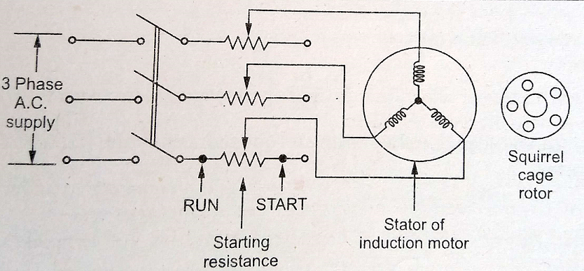

**Fig. 4.5. Stator resistance Starter**

1. **Autotransformer starter**

This method also aims at connecting the induction motor to a reduced supply at starting and then connecting it to the full voltage as the motor picks up sufficient speed. Fig.4.6. shows the circuit arrangement for autotransformer starting. The tapping on the autotransformer is so set that when it is in the circuit, 65% to80% of line voltage is applied to the motor. At the instant of starting, the change-over switch is thrown to “start” position. This puts the autotransformer in the circuit and thus reduced voltage is applied to the circuit. Consequently, starting current is limited to safe value. When the motor attains about 80% of normal speed, the changeover switch is thrown to “run” position. This takes out the autotransformer from the circuit and puts the motor to full line voltage.

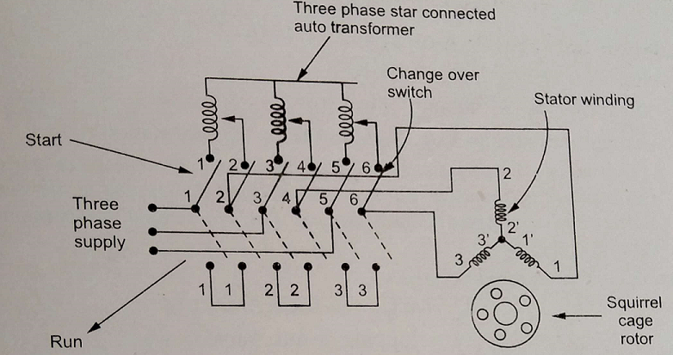

**Fig. 4.6. Autotransformer starter**

**Relation between starting and Full Load torques**. Consider a star-connected squirrel-cage induction motor. If V is the line voltage, then voltage across motor phase on direct switching is V/√3 and starting current is Ist = Isc. In this case the phase voltage across motor is K*V/√3 and Ist = K*Isc, Where K is the fraction of applied voltage to the stator by autotransformer tapping.

Hence the ratio of staring torque and full load torque is





1. **Star-Delta starter**

The stator winding of the motor is designed for delta operation and is connected in star during the starting period. When the machine is up to speed, the connections are changed to delta. The circuit arrangement for star-delta starting is shown in Fig.4.7.

The six leads of the stator windings are connected to the changeover switch as shown. At the instant of starting, the changeover switch is thrown to “Start” position which connects the stator windings in star. Therefore, each stator phase gets  volts where V is the line voltage. This reduces the starting current. When the motor picks up speed, the changeover switch is thrown to “Run” position which connects the stator windings in delta. Now each stator phase gets full line voltage V.

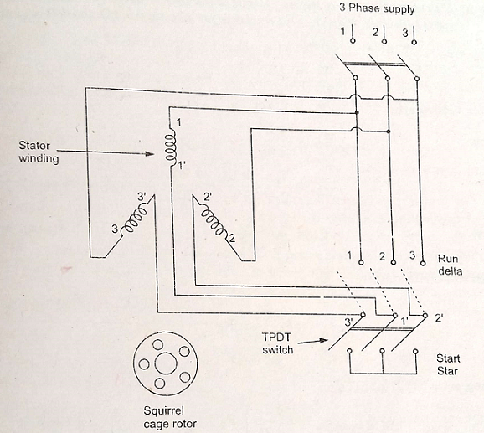

**Fig.4.7. Star-Delta starter**

**Relation between starting and Full Load torques**.

In direct delta starting, (Fig. 4.8)

Starting current/phase, Isc = V/Zsc where V = line voltage

Starting line current = 3 Isc

In star starting, we have, (Fig.4.8)

Starting current/phase, 

Now 



where Isc = starting phase current (delta)

If = F.L. phase current (delta)

Note that in star-delta starting, the starting line current is reduced to one-third as compared to starting with the winding delta connected. Further, starting torque is reduced to one-third of that obtainable by direct delta starting. This method is cheap but limited to applications where high starting torque is not necessary e.g., machine tools, pumps etc.



**Fig.4.8 Voltage – current relation in Star-Delta**

The disadvantages of this method are:

(a) With star-connection during starting, stator phase voltage is times the line voltage. Consequently, starting torque is or 1/3 times the value it would have with D-connection. This is rather a large reduction in starting torque.

(b) The reduction in voltage is fixed.

This method of starting is used for medium-size machines (up to about 25 H.P.).

1. **Direct On Line starter**

In case of small rating of motors less than 5hp, the starting current is not very high and such

motors can withstand that starting current without any starter. So there is no need to reduced applied voltage to control starting current. Hence such motors are directly connected to the supply without any reduction voltage. Hence such type of starters is called Direct On-Line (DOL) Starter.

The fig.4.9 shows the arrangement of DOL starter. This starter has Overload protection and no volt protection (if supply fails starter will OFF automatically)

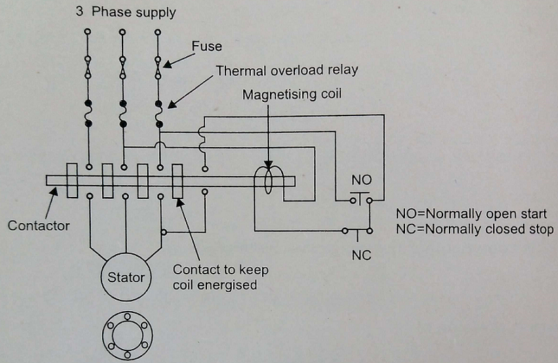

**Fig.4.9 Direct On Line starter**

1. **Rotor resistance starting**

This method allows external resistance to be connected to the rotor through slip rings and brushes. Initially, the rotor resistance is set to maximum and is then gradually decreased as the motor speed increases, until it becomes zero.

The rotor impedance starting mechanism is usually very bulky and expensive when compared with other methods. It also has very high maintenance costs. Also, a considerable amount of heat is generated through the resistors when current runs through them. The starting frequency is also limited in this method. However, the rotor impedance method allows the motor to be started while on load.

Figure 4.10 shows the connection of a 3phase induction motor with rotor resistance starter.

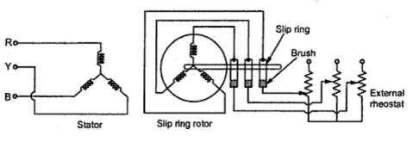

**Fig. 4.10. Connections of rotor resistance starter**

To limit the rotor current which consequently reduces the current drawn by the motor from the supply, the resistance can be inserted in the rotor circuit at start. This addition of the resistance in rotor in the form of 3 phase star connected rheostat. The arrangement is shown in the Fig. 4.10.The external resistance is inserted in each phase of the rotor winding through slip ring and brush assembly. Initially maximum resistance is in the circuit. As motor gather speed, the resistance is gradually cut-off. The operation may be manual or automatic.

       We have seen that the starting torque is proportional to the rotor resistance. Hence important advantage of this method is not only the starting current is limited but starting torque of the motor also gets improved.

**Note**: The only limitation of the starter that it can be used only for slip ring induction motors as in squirrel cage motors, the rotor is permanently short circuited.